**Friends and Family Test**

Custom House Medical Teaching & Training Practice collects patient responses for the NHS Friends and Family Test to determine if you would recommend our service and why. Your feedback will be anonymous and will help us to continuously improve our service. Please collect a card at reception.

**Services Available**

|  |  |  |  |
| --- | --- | --- | --- |
| Diabetes | CD Rationalisation & Medication Optimisation Clinic | Young Persons Clinic | Women's Health |
| Women's Health | Chronic Disease Management | Antenatal & Postnatal Clinics | COPD Review |
| Asthma | Primary Prevention (CVD / Pre Diabetes Reviews) | COPD Case finding | Mental Health Clinic / Long Term Conditions |
| Learning Disabilities | New patient checks | Over 40's Health Check | Childhood immunisation |
| Travel Vaccinations | Wound / Dressing | Well women Clinic | Cervical Cytology Clinic |
| Phlebotomy (blood tests) | Latent TB | Talking Therapy | Community Mental Health Team |
| Counsellor | Stoma Care |  |  |

**Online Services**

The practice offers patients the ability to book routine GP appointments as well as to request repeat medication online via the ‘patient access’ service. Please speak to our reception team so that you can register for the service. Our website can be located at www.customhousesurgery.co.uk and is updated regularly with practice news and information.

**Useful telephone numbers**

|  |  |
| --- | --- |
| NHS 111 | 111 |
| Newham General Hospital | 020 7476 4000 |
| Royal London Hospital | 020 7377 7000 |
| Barts Health NHS Trust | 020 73777 000 |
| Newham Rise | 0800 652 3879 |
| Newham Citizens Advice | 020 8525 6377 |
| Appleby Health Centre | 020 7445 7000 |



**Custom House Medical Teaching & Training Practice**

16 Freemasons Rd, London E16 3NA

020 7476 2255

Fax: 020 7511 8980

Web: www.customhousesurgery.co.uk

**We aim to provide dedicated patient care in an environment which is efficient, calm and conductive to promoting good health.**

**To provide our patients with high quality, accessible care in a safe, responsive and courteous manner**

**SURGERY OPENING HOURS**

**Monday to Friday 0800-1830**

**Saturday 0800-1300 (pre-booked appointments only)**

**Telephone Access is available Monday till Friday 0800-1830**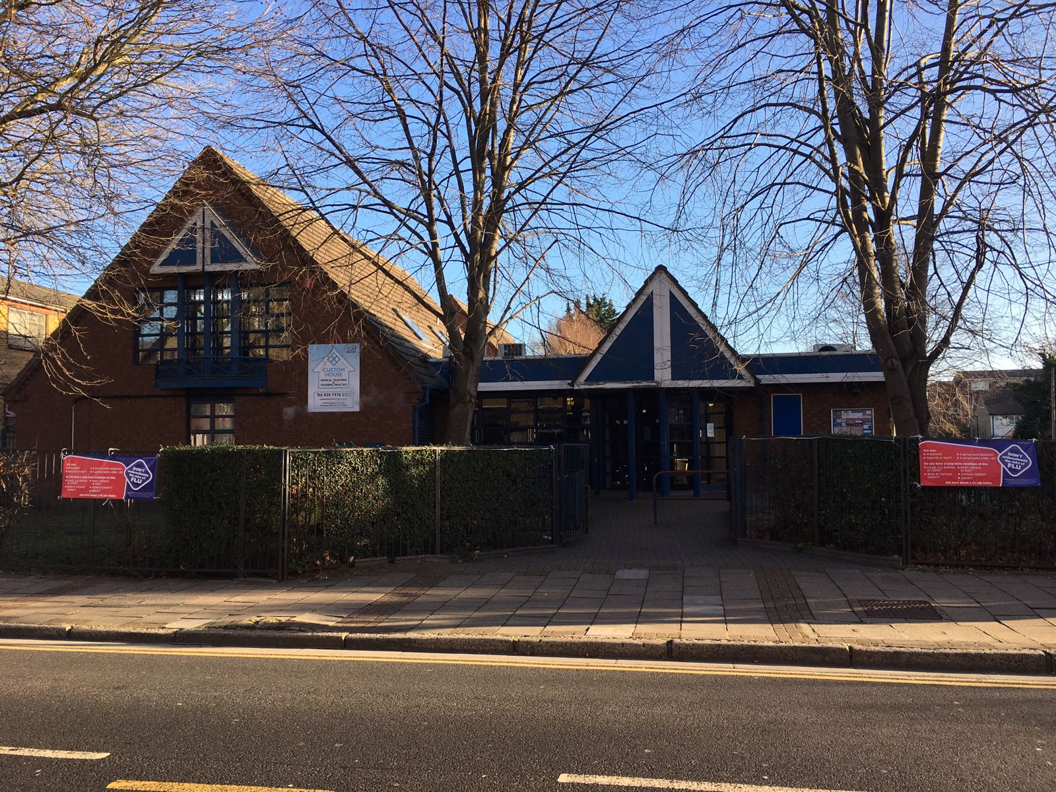

**Making an urgent appointment**

We also offer same day appointments for urgent medical matters that cannot wait. Please try to call as close to 8am as possible on 020 7476 2255. You may also be offered the option to speak to a doctor/Nurse to triage your medical query. If you are housebound or too ill to get to the practice you can request to be seen at home. Requests for visits should be made before 1300.

**Repeat Prescriptions**

If you need a repeat prescription you should tick the medications you need on the re-order part of your previous prescription. A stamped addressed envelope must be attached if you wish the prescription to be posted to you. You can also request repeat medication via the patient access. We will make every effort to ensure your request is processed within 2 working days from the day we receive it. Allow three days for postage. There could be a delay if there are any queries or unusual items which have been requested. Please be aware these queries are for your own safety. It is your responsibility to order your medication in time.You may need to speak to a doctor if you request items that are not on your list of regular prescriptions.

For your safety and confidentiality reasons we do not take requests for repeat prescriptions over the telephone.

**Out of hours**

During the hours that the practice is closed, for urgent matters that cannot wait until the practice reopens please contact GP Co-operative by dialling the surgery number on 020 7476 2255, alternatively call 111 (free from mobiles and landlines). In a life-threatening emergency please call 999.

**Complaints and suggestions**

The doctors and staff at the practice are committed to providing high quality healthcare and services to patients. We value your views and feedback as we think it plays an essential part in constantly improving the services we offer. Please speak to reception for a copy of the practice complaints procedure or ask to speak to the practice manager if you wish to make a complaint. Alternatively, you may wish to join our Patient Participation Group so that you can offer your feedback at our regular meetings.

**Registering with the Surgery**

Application for new registration will take **10 working days** to process. Please bring photo ID (Passport) and a recent utility bill, rental contract, details of your previous doctor including their address, your Medical Card if you have one and your NHS number. We must have all the relevant information before we can commence registration. We are currently registering new patient’s everyday between 11:30 – 15:00 and on Tuesday, Wednesday & Thursday 17:00-17:30.   It would help to speed your registration up if you can bring your NHS number.

**If registering a child under 5 years of age you must bring in the red book or proof of previous immunisations.** Female patients will need to bring in details of their last smear test.

*Note: Please inform the practice if you change your address and ensure that we have the most up-to-date contact details for yourself and your next of kin.*

**Our Staff**

**Doctors:** Dr Tsegaye, Dr Patti, Dr Kumar, Dr Barot

**Advanced Nurse Practitioner:** Sarah Loi

**Clinical Pharmacist:** Andrea Santomieri

**Practice Nurses:** Pat Munroe & Mary Kentish

**Healthcare Assistant:** Bozhana Vasileva

**Practice Manager**: Mohammed Al-Mahfuz

**Patient Liaison Manager**: Glynis Webb

**Reception/Admin Team**: Bobbi, Val, Aaron, Kim, Marie, Rebecca, Stacy, Tracy, Donna and Lesley

**Making a routine appointment**

The practice offers routine appointments up to 14 days in advance with the additional ability to book appointments online via the patient access service (please speak to reception to register for this service). Routine appointments with doctors and nurses can be booked between 0800 and 1800.